**Access S3 from Private EC2 instance using VPC Endpoint**

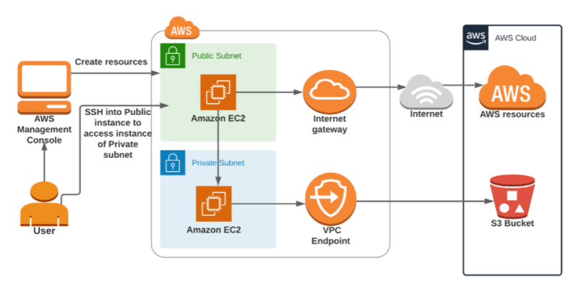

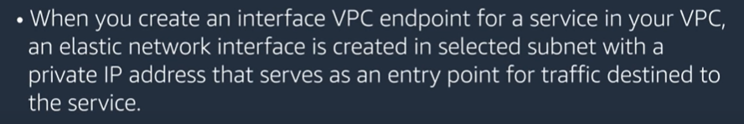

Create VPC

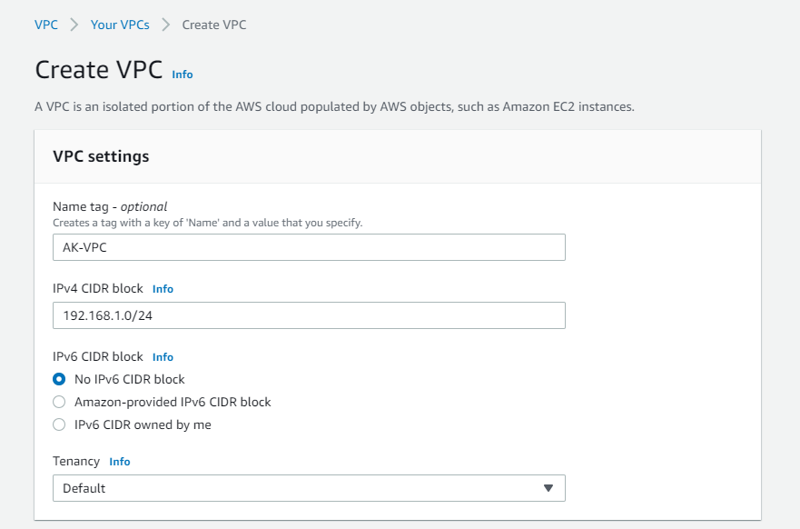

Create IGW and attach it to VPC

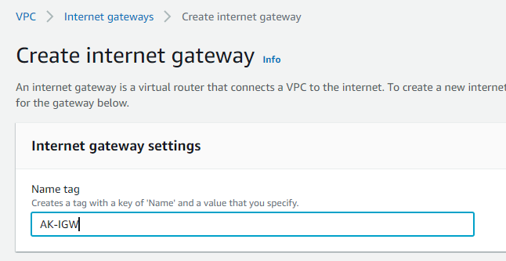

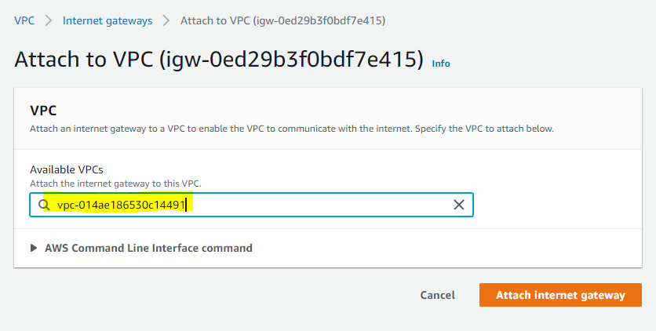

Create subnet

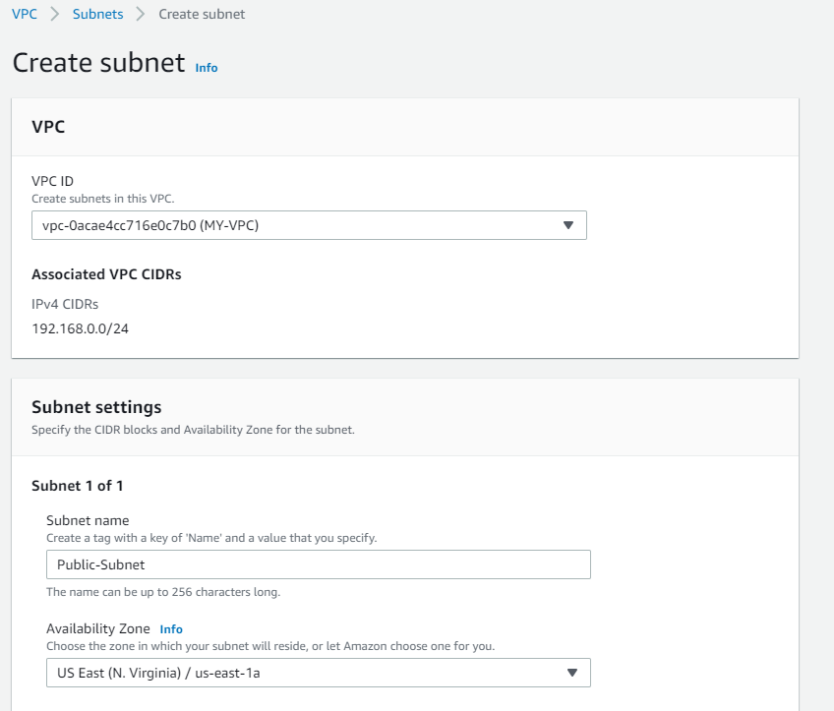

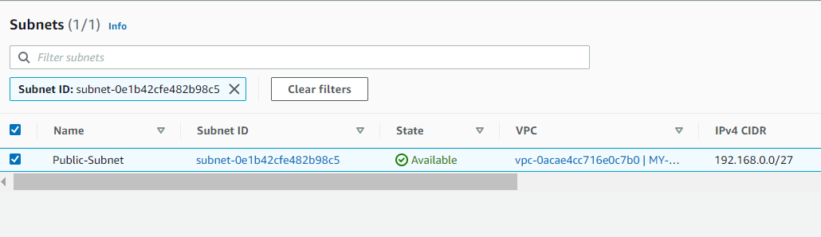

Create private subnet

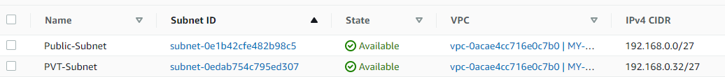

Edit subnet setting

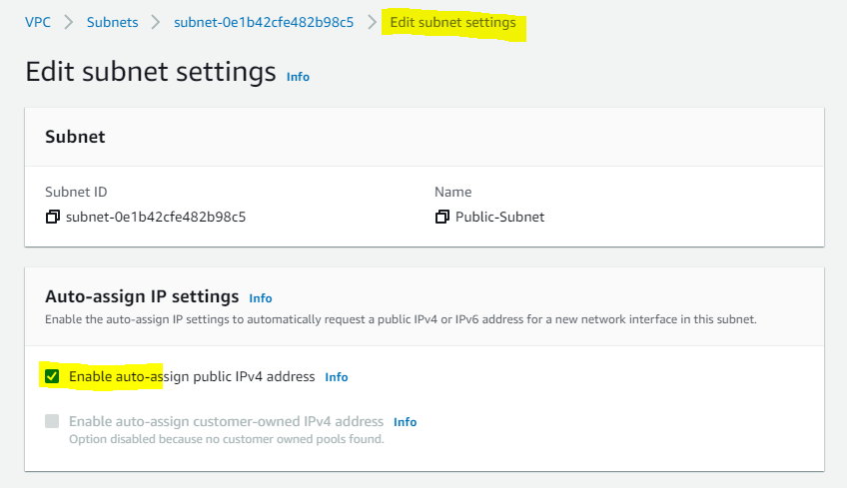

Edit route table

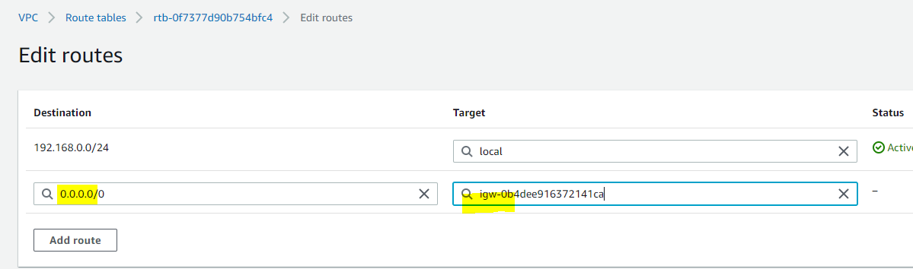

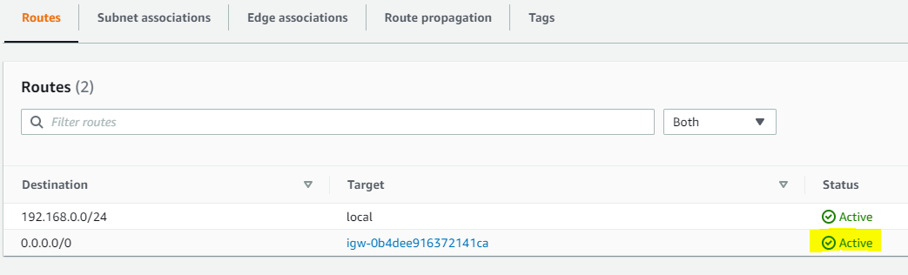

Create RT for private subnet

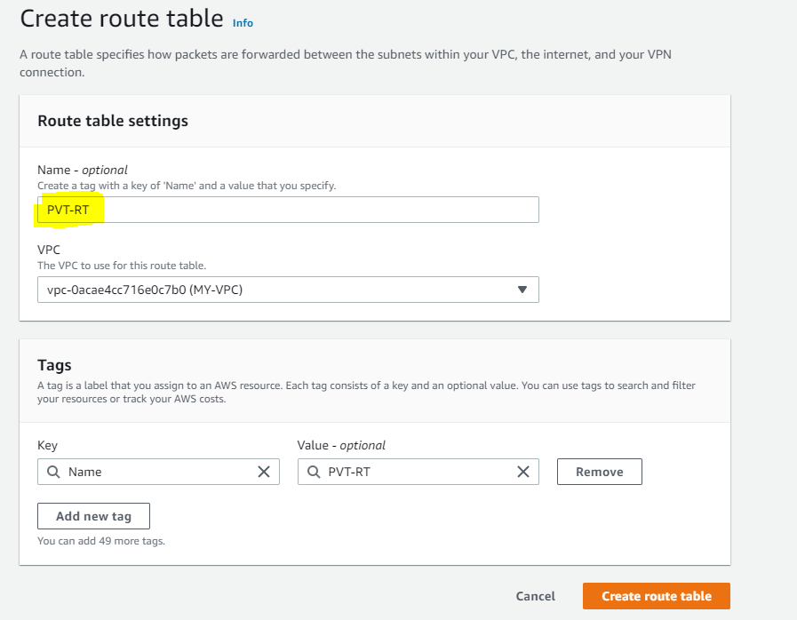

Edit subnet association

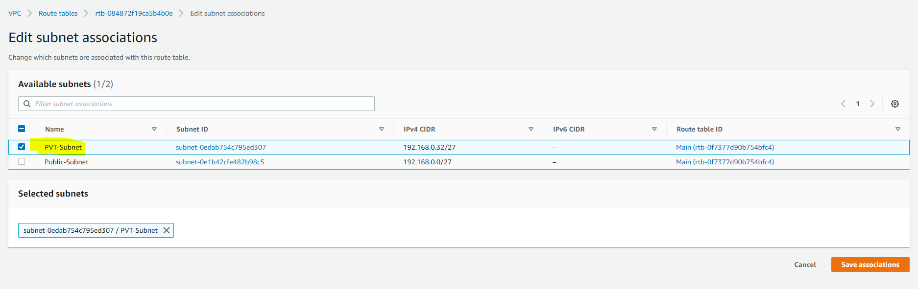

Create two Ec2 instances one with public and another private subnet.

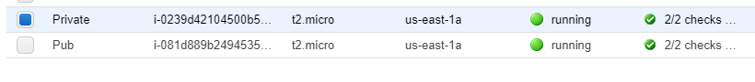

Create S3 bucket and upload some objects. Now try accessing s3 object from public instance using S3 url. It is accessible.

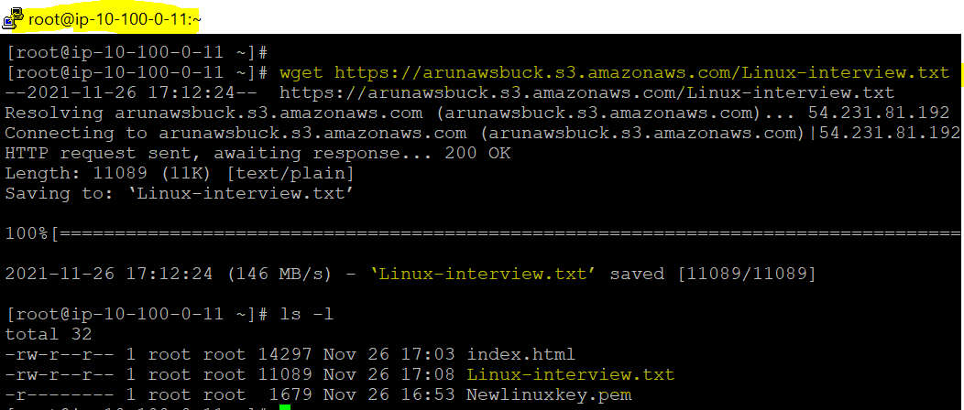

Now try accessing s3 object from private subnet using S3 url. It wont work because this instance not having internet connection in this case VPC end point going to help us.

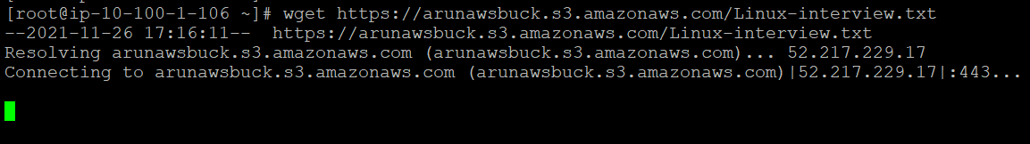

Create VPC endpoint

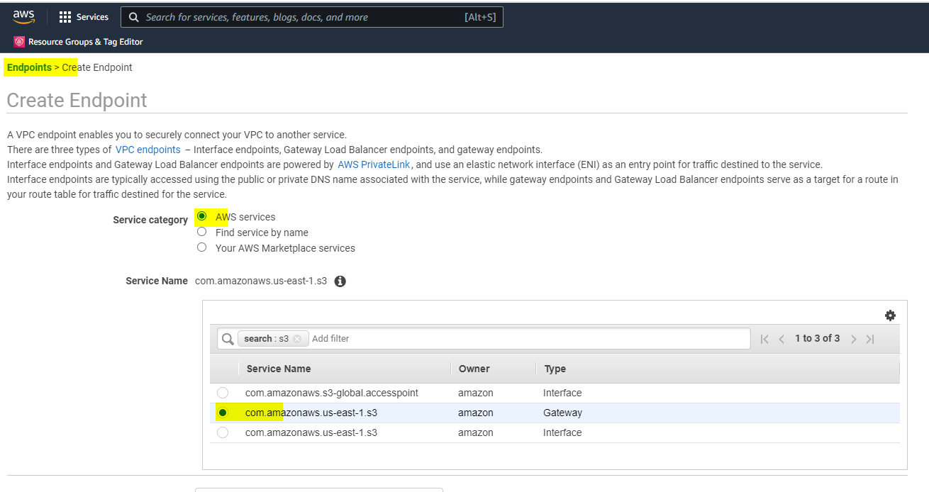

Select VPC and choose private subnet

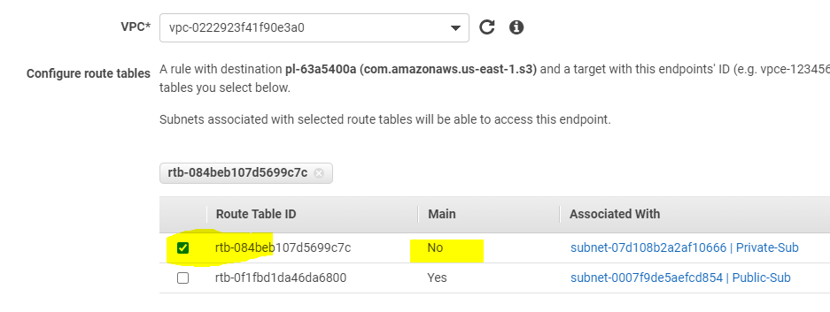

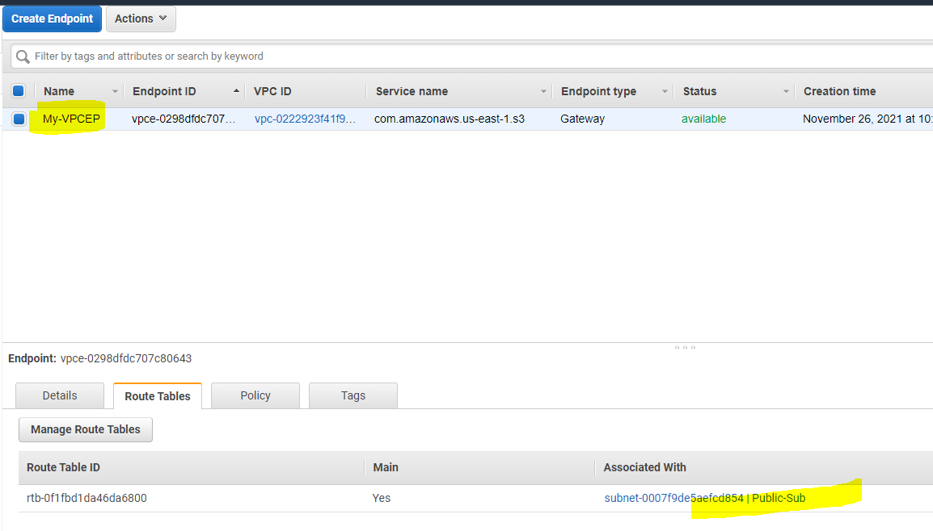

To verify end point switch to RT and check routes in private subnet we can see end point entry.

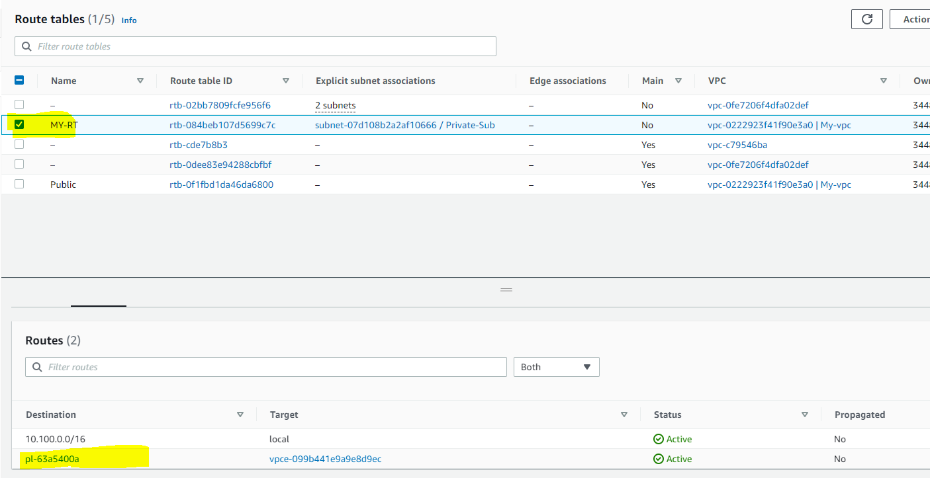

Once Endpoint configured try access S3 url. Now it will works.

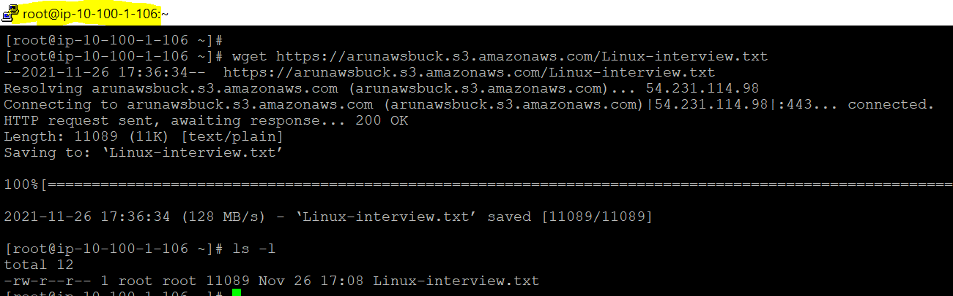

We not access S3 through internet we accessed using only using VPC endpoint.

